STOCK PRICE PREDICTION

# INTRODUCTION

Stock Price Prediction using machine learning helps you discover the future value of company stock and other financial assets traded on an exchange. The entire idea of predicting stock prices is to gain significant profits. Predicting how the stock market will perform is a hard task to do.This is an automatically generated kernel with starter code demonstrating how to read in the data and begin exploring.

In this phase the building and loading of data flow of stock price is going to be done.

## PREREQUISITES FOR BUILDING A STOCK PREDICTION MODEL

* The data is obtained from [https://www.Kaggle.com/data](https://www.kaggle.com/data)
* Have the following libraries installed — Numpy, Pandas, Matplotlib, Seaborn, Scikit-Learn, Kneed, and Scipy.
* Columns Required from dataset

1. Date
2. Open
3. High
4. Low
5. Close
6. Adj Close
7. Volume

## UNDERSTAND THE PREDICTION DATA

Before starting any data science project, it is vital to explore the dataset and understand each variable.

* Libraries Imported :

1. Numpy
2. Pandas
3. Matplotlib
4. Seaborn

* Loading the Data

**df=pd.read_csv(‘/kaggle/input/msft/MSFT.csv’)**

* let’s look at the head of the dataframe:

**df.head()**

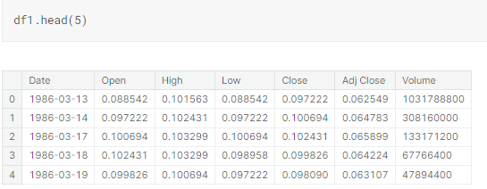

## PREPROCESSING DATA FOR PREDICTION

The raw data we downloaded is complex and in a format that cannot be easily ingested by customer segmentation models. We need to do some preliminary data preparation to make this data interpretable.

* Distribution

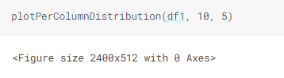

* Correlation Matrix

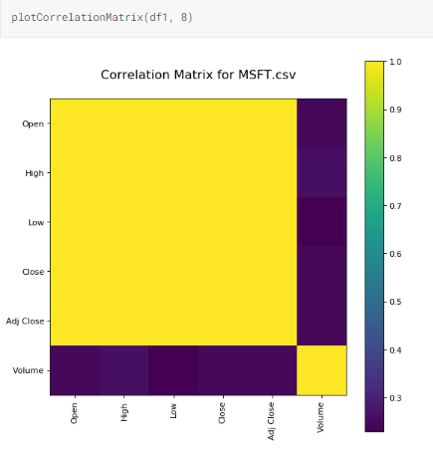

## BUILDING THE STOCK PREDICTION MODEL

  We are going to create a K-Means clustering algorithm to perform customer segmentation.The goal of a K-Means clustering model is to segment all the data available into non-overlapping sub-groups that are distinct from each other.

plotScatterMatrix(df1, 18, 10)

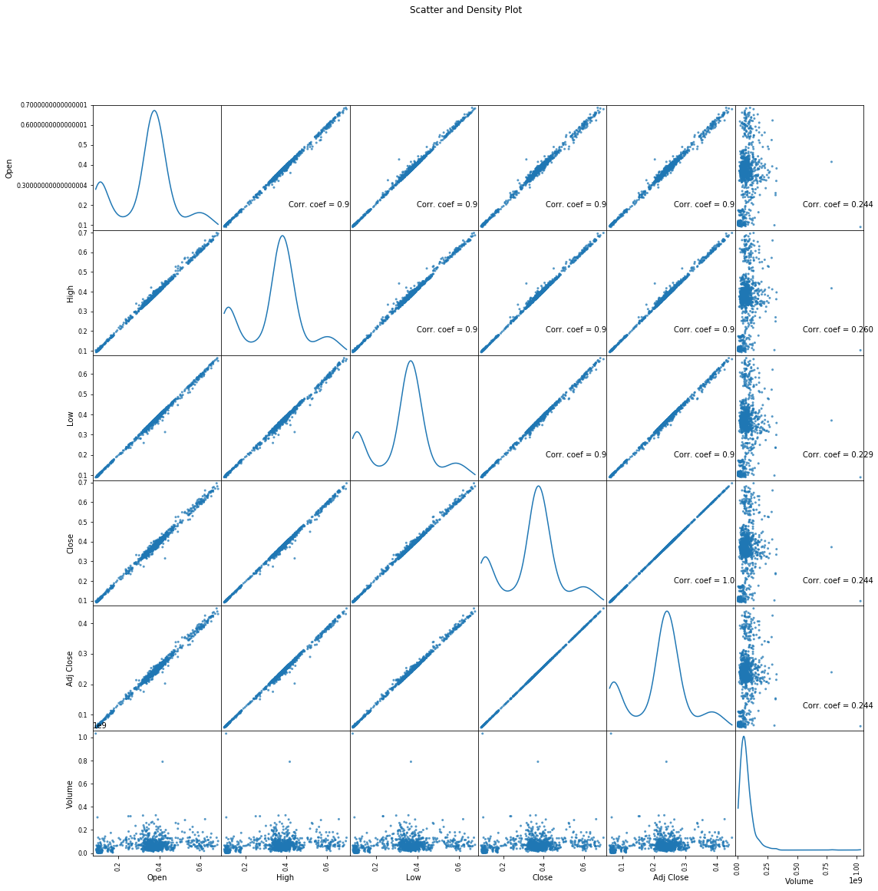

PICTORIAL REPRESENTATIONS

